Open Source Communities and
Development Process

Version : 1.0
Document Owner : Richard Raju

Document Control Information

 | Role | Name | Date
Document Prepared by |  | Richard Raju | 06/11/2011
Reviewed by
Approved by

Revision History:

Version  Number | Revision  Date | Description of Changes
1.0 | 05-11-2011 | Initial Version

Course Details

Course Name | Open source and Open Standard
Semester | First
Credits | 2
Chapter | 3
Delivery Duration | 3 Hour

Table of ContentS

1 Open Source Initiative (OSI) 5
1.1 Open source definition 5
1.2 The License Review Process 6
2 Free Software Foundation 7
3 Open Source Development Process 8
3.1 Open Source Community 9
3.2 Apache web server 10
4 How to Contribute to Open Source Projects? 12
5 References 13
6 Disclaimer 14

Open Source Initiative (OSI)

Eric S. Raymond paper “The Cathedral and the Bazaar” had a galvanizing effect because it articulated a clear technical and behavioral logic with which the open source community could identify. And his subsequent presentation at O'Reilly Perl Conference which triggered Netscape the then popular web browser to release the source code. OSI was jointly founded by Eric Raymond and Bruce Perens in late February 1998.

The Open Source Definition was derived from the Debian Free Software Guidelines. Bruce Perens had initially drafted it and was refined using suggestions of the Debian GNU/Linux Distribution developers.

Open source definition

Here is the extract of Open source definition from opensource.org

1. Free Redistribution

The license shall not restrict any party from selling or giving away the software as a component of an aggregate software distribution containing programs from several different sources. The license shall not require a royalty or other fee for such sale.

2. Source Code

The program must include source code, and must allow distribution in source code as well as compiled form. Where some form of a product is not distributed with source code, there must be a well-publicized means of obtaining the source code for no more than a reasonable reproduction cost preferably, downloading via the Internet without charge. The source code must be the preferred form in which a programmer would modify the program. Deliberately obfuscated source code is not allowed. Intermediate forms such as the output of a preprocessor or translator are not allowed.

3. Derived Works

The license must allow modifications and derived works, and must allow them to be distributed under the same terms as the license of the original software.

4. Integrity of the Author's Source Code

The license may restrict source-code from being distributed in modified form only if the license allows the distribution of "patch files" with the source code for the purpose of modifying the program at build time. The license must explicitly permit distribution of software built from modified source code. The license may require derived works to carry a different name or version number from the original software.

5. No Discrimination against Persons or Groups

The license must not discriminate against any person or group of persons.

6. No Discrimination against Fields of Endeavor

The license must not restrict anyone from making use of the program in a specific field of endeavor. For example, it may not restrict the program from being used in a business, or from being used for genetic research.
7. Distribution of License

The rights attached to the program must apply to all to whom the program is redistributed without the need for execution of an additional license by those parties.
8. License Must Not Be Specific to a Product

The rights attached to the program must not depend on the program's being part of a particular software distribution. If the program is extracted from that distribution and used or distributed within the terms of the program's license, all parties to whom the program is redistributed should have the same rights as those that are granted in conjunction with the original software distribution.

9. License Must Not Restrict Other Software

The license must not place restrictions on other software that is distributed along with the licensed software. For example, the license must not insist that all other programs distributed on the same medium must be open-source software.
10. License Must Be Technology-Neutral

No provision of the license may be predicated on any individual technology or style of interface.

The License Review Process

The purpose of OSI license review process is to ensure approved licenses conform to the Open Source Definition, falls under appropriate License proliferation Category (to know more on this please visit http://opensource.org/proliferation-report), avoid duplication and transparent and timely review.

Request Submission:

Request can be submitted for one of the following types;

- Retirement - A request retire the license. This request can only be made by the license
steward
- Legacy Approval - Retroactive approval of historic/legacy licenses that have already been extensively used by an existing community, but have not previously been approved.
- Approval - Approval of completely new licenses, or licenses previously used by only a single entity

Review:

The license review community will discuss for at least 30 days. Then, License Review Chair will summarize and present recommendations to OSI Board which will request additional information if need be and make final decision. A report will be submitted to License review committee which will approve or reject.

Free Software Foundation

Free software Foundation is a non-profitable organization founded in 1985 by Richard Stallman. The primary motive is to promote freedom to use, modify and distribute software. FSF management consist of, Richard Stallman as President, John Sullivan, Executive Director and Ward Vandewege, Chief Technology Officer. FSF has over 3,000 active members in 48 countries, representing a diverse membership of computer users, artists, software engineers, hackers, students, and activists.

The FSF sponsors the GNU project. The ongoing effort to provide a complete operating system licensed as free software. FSF’s Free Software Licensing and Compliance Lab has been an informal activity of the FSF since 1992 and was formalized in December 2001. They handle all licensing-related issues for FSF. They work around GNU GPL and free software licensing, and enforcing the license on FSF-copyrighted software. The FSF publishes the GNU General Public License (GNU GPL), widely used free software license. FSF is copy-left based movement. This was discussed in detail in pervious chapter.

Free Software Foundation of India

The Free Software Foundation of India is an Indian sister organization to the US-based Free Software Foundation. FSFI was founded in Thiruvananthapuram, Kerala in 2001. They have been working with many scientist and professionals to promote open source software.

Vision of FSF India (An extract from www.gnu.org.in)
- Promote awareness about free software among the general public and, specifically, among programmers and students.
- Increase access to free software by users in India.
- Promote the development of local solutions to local problems by empowering local programmers in the use of free platforms, tools and technologies.
- Provide support to free software by way of documentation, expert help or any other means.
- Help organize training for programmers and users of free software platforms and software.
- Carry out R&D work for free software solutions to suit local requirements.
- Provide services for the free software programmer community by, for example, locating and distributing jobs.
- Assist the national and State governments in all aspects relating to free software, such as evolving and maintaining standards; providing a quality assurance mechanism for free software; and ensuring the use of free software in government and quasi-government milieux.
- Provide services such as adjudication and conflict redressal within the free software domain.
The term “open source” software is used by some people to mean more or less the same category as free software. It is not exactly the same class of software: they accept some licenses that we consider too restrictive, and there are free software licenses they have not accepted. However, the differences in extension of the category are small: nearly all free software is open source, and nearly all open source software is free.
— Free Software Foundation, http://www.gnu.org/philosophy/categories.html

Open Source Development Process

Call for Contributions

“Starting this Thanksgiving I am going to write a complete Unix-compatible software system called GNU (for Gnu's Not Unix), and give it away free to everyone who can use it. Contributions of time, money, programs and equipment are greatly needed”

Richard Stallman wrote this above message which was displayed to user who logged into Usenet newsgroup during the spring of 1983. He did not have success in the beginning but after persistent attempts he was able to release GNU Emacs text editor. Finally, GNU had something to show. As more and more programmers started contributing, Stallman with help of his co-workers formed Free Software Foundation (FSF).

MythBuster

Eric S. Raymond the author of “Cathedral and the Bazaar” pointed 2 kinds of software development. The first is like building a cathedral, with complete planning from start to finish this was followed in closed source development. This was more or less followed by FSF. Eric also observed in one of the conference delivered by Richard Stallman and Linux Torvalds, where Torvalds had found a way around Brook’s Law.

Brook’s Law:

Fred P. Brooks, manager of IBM's OS/360 project and author of the 1975 book, The Mythical Man-Month, Brooks' Law held that adding developers to a project only resulted in further project delays. He also says that, as the number of programmers working on a project rises (to n), the work that gets done scales at best by n—but vulnerability to bugs scales as the square of n. Meaning, the problem are created faster than it creates solutions.

Too many cooks spoil the broth; conversely, many hands make light work. Torvalds actually found a way to use more hands to develop better software. This is the second type of software development; Eric called this “The Bazaar”, where coherent systems are built with mass contributors with absence of hierarchical model.

Nevertheless, when masses of highly motivated people collaborate to the open source it is a customary to have conflicts. Most of these conflicts hover around, who makes the final decision? Who gets the credit for the contribution? At times when the conflicts get hotter some people tend to break away and start their own version of the software. This is called “forking”. We will discuss more on this in the next chapter in “Challenges and Mitigation”.

During the BSD development, team had put together decentralized, mass contribution, internet based development effort to write software code. The de facto standard was to add names in the credits list. The core team coordinated the contributions of a larger network of volunteer programmers who sent in contributions. As contributors grew from strength to strength this setup did not work effectively.

Open source software development process has been unstructured because no clear development tools and phases were defined. Many open source communities have demonstrated that a large and complex system of software code can be built, maintained and developed where many developers work in a highly parallel, relatively unstructured way as opposed to a proprietary organizations. Every project has its own phases of development, code maintenance and release.

Open Source Community

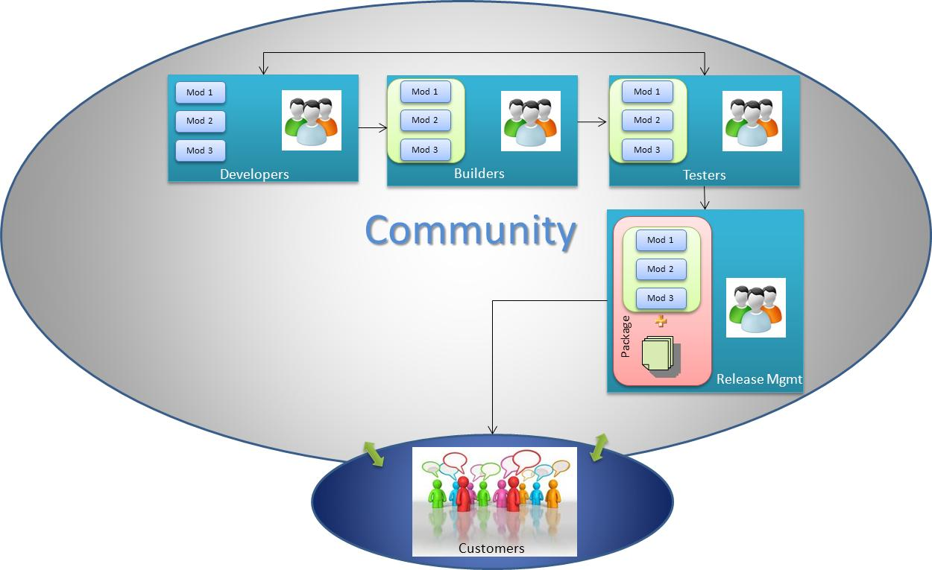

Developers: They are responsible for coding of different modules of the open source software

Builder: They work on these modules to build a new version of the software

Testers: They take the software build and test the software functionality. In case of a failure they report back to the developers

Release Management: They package the final version of the software along with necessary documents.

Apache web server

Web Server: A web server is a computer that stores websites on the Internet and delivers web pages to the requester.

During the early 1995 most popular web server software was HTTP daemon developed by Rob McCool at National Center for Supercomputing Applications (NCSA), University of Illinois. AS Rob left NCSA development on HTTP stalled. But, a small group of enthusiastic developers continued to work on it via e-mail. The developers coordinated the changes with exchange of patches. This was a very tedious and ineffective process to follow. Brian Behlendorf and Cliff Skolnick came to their rescue and put together required machines and bandwidth (donated) for developer to communicate their changes efficiently. Eight core contributors namely Brian Behlendorf, Roy T. Fielding, Rob Hartill, David Robinson, Cliff Skolnick and Randy Terbush along with three additional contributors Eric Hagberg, Frank Peters and Nicolas Pioch formed the foundation of the original “Apache Group”.

Using the original NCSA code with added patches they released the first official public release (0.6.2) of the Apache server in April 1995. Thereafter multiple enhancements were done on Apache. To this day, it is the most widely used web server in the world.

Apache Software Foundation(ASF)

As the internet grew the popularity of Apache web server increased. The need for a more structured organization and process was necessary. In 1999 the Apache Group incorporated as a nonprofit organization, the Apache Software Foundation. Due to ASF popularity, technical merits and to the openness there were several separate communities each focused on a different side of the "web serving" problem. These separate communities were referred to as "projects".
It has multiple projects under its umbrella namely, Jakarta, Perl, TCL, and others. Each of these projects has their own project management committee and Apache Software Foundation board of directors is responsible for overall direction, coordination among the different projects.

People are given access to code repository based on basic principle of meritocracy meaning based on the individual merits. This is not based on votes but on merit. This worked well because most of the contributors are volunteers who wanted to help by bringing in few features or fixing a bug. The meritocracy enables various roles; (extract from http://www.apache.org)

User

A user is someone that uses our software. They contribute to the Apache projects by providing feedback to developers in the form of bug reports and feature suggestions. Users participate in the Apache community by helping other users on mailing lists and user support forums.

Developer

A developer is a user who contributes to a project in the form of code or documentation. They take extra steps to participate in a project, are active on the developer mailing list, participate in discussions; provide patches, documentation, suggestions, and criticism. Developers are also known as contributors.

Committer

A committer is a developer that was given write access to the code repository and has a signed Contributor License Agreement (CLA) on file. They have an apache.org mail address. Not needing to depend on other people for the patches, they are actually making short-term decisions for the project. The PMC can (even tacitly) agree and approve it into permanency, or they can reject it. Remember that the PMC makes the decisions, not the individual people.

PMC Member

A PMC member is a developer or a committer that was elected due to merit for the evolution of the project and demonstration of commitment. They have write access to the code repository, an apache.org mail address, the right to vote for the community-related decisions and the right to propose an active user for committership. The PMC as a whole is the entity that controls the project, nobody else.

PMC Chair

The Chair of a Project Management Committee (PMC) is appointed by the Board from the PMC Members. The PMC as a whole is the entity that controls and leads the project. The Chair is the interface between the Board and the Project.

ASF Member

An ASF member is a person who was nominated by current members and elected due to merit for the evolution and progress of the foundation. Members care for the ASF itself. This is usually demonstrated through the roots of project-related and cross-project activities. Legally, a member is a "shareholder" of the foundation, one of the owners. They have the right to elect the board, to stand as a candidate for the board election and to propose a committer for membership. They also have the right to propose a new project for incubation (we'll see later what this means). The members coordinate their activities through their mailing list and through their annual meeting.

Project Management and Collaboration

The Apache projects are managed using a collaborative, consensus-based process. Since the appointed Project Management Committees (PMPC) have the power to create their own self-governing rules, there is no single vision on how PMCs should run a project and the communities they host. At the same time, while there are some differences, there are a number of similarities shared by all the projects:

Communication

Communication is done via mailing lists. Where conversations happens asynchronously. Some projects additionally use more instant messaging for synchronous communication. Each project is responsible for its own project website.

Decision Making

Projects are normally auto governing and driven by the people who volunteer for the job. When coordination is required, decisions are taken with a lazy consensus approach: a few positive votes with no negative vote are enough to get going.

How to Contribute to Open Source Projects?

There are tens of thousands of open source projects out there. Many of us download the code, compile it and install it. We might even deploy it in our production and running them. Then you discover there's a bug. Now, you might try to figure out how to fix it by going through number of discussion lists, forums and the developer lists. We might also innovatively think about new features to add to the product. Programmers might also find a way to add these features to the product. Question is, How can anyone be involved and contribute to open source, be a programmer or just a user. Below is a short list that might help us to understand on how to contribute to open source.

What is your interest?

Look for a project which enthralls you. Do not pick projects based on your knowledge on the programming language but your domain of interest. For example, just by knowing Java you may be able to work on gaming project

Evaluate the community

After choosing a project of interest, look for the projects community and there activities. Check out the project web site, they might have process for contribution, guidelines and communication channel. Most projects have a differentiation between the users list and the developers list.

Committers

Committers’ are the ones who commit the code. Every project will have one or more committers.
Your code should be committed via them. Common practice is to release a patch with the changes we have made in the code but sometimes a modified code is sent to committers. Either way, it is committer’s responsibility to update the code.

Eureka! Eureka! I have found a bug, good now report it

The best place to start with any open source project is by finding and reporting a bug. This helps because bugs take a long time to get from first being noticed to being resolved. A veteran programmer with the community may dive in and fix the bug. But it is still a tedious job. This will also help contributor with meritocracy.

Meritocracy

There may not be financial rewards in open source but meritocracy is nothing less than a reward for developers who are engaged in community activities. Many projects assign roles based on meritocracy. Therefore, being actively involved and loyalty has a reward.

Testing and Documentation

Apart from coding there are various ways to contribute as well. You can be involved in writing documentation, Translation to different languages, answer questions on forums and donate hardware, last but not the least tons of appreciation.

References

- http://www.apache.org

- www.gnu.org.in

- http://opensource.org

Disclaimer

The contents of this report reflect the views of the author and do not necessarily reflect the official views or policy of the International Business Machines Corporation in the United States and/or other countries. This report does not constitute a standard, specification or regulation.

IBM is a registered trademark of International Business Machines Corporation in the United States and/or other countries.

Other company, product, and service names may be trademarks or service marks of others.

Microsoft is a registered trademark of Microsoft Corporation

